STANDING ORDER FOR COMPENSATION OF ATTORNEYS APPOINTED TO REPRESENT INDIGENT DEFENDANTS

On the day of 200 :) the below named County/District Judges with criminal jurisdiction, after a duly called and conducted meeting and discussion, did unanimously adopt this schedule of fees concerning compensation of court-appointed counsel for indigent Defendants and related expenses made pursuant to Article 26.05, Texas Rules of Civil Procedure: therefore, it is ORDERED that compensation of court-appointed counsel and related expenses, made pursuant to a motion in the format prescribed by the appointing court, shall be as follows on a case-by-case basis as determined by the Judge:

- NON-FELONY CASES

  - Compensation for time spent by counsel out of court shall be not less than FORTY DOLLARS AND NO CENTS ($40.00) per hour nor more than NINETY DOLLARS AND NO CENTS ($90.00) per hour.

  - Compensation for time spent in court shall not be less than FIFTY DOLLARS AND NO CENTS ($50.00) per hour nor more than NINETY DOLLARS AND NO CENTS ($90.00) per hour.

- CAPITAL CASE COMPENSATION

Inall capital cases the rates for the attorney's services shall be no less than $70.00 per hour and no more than $100.00 per hour.

- REIMBURSEMENT FOR REASONABLE EXPENSES FOR PURPOSES OF INVESTIGATION AND EXPERT TESTIMONY

A. In all criminal cases appointed counsel will be reimbursed for reasonable expenses that are incurred provided prior court approval has been granted upon motion, application and a hearing held on said motion.
Reasonable expenses upon prior court approval after motion and application, may include expenses incurred for investigation and expert testimony, and will be in addition to the total compensation referred to in Section I of this Order.

- REQUEST FOR PAYMENT OF ATTORNEY'S FEES AND EXPENSES

Each attorney shall prepare a detailed statement of the nature of the services performed, the date of such performance, and the actual time spent on each such date and service, and shall submit said statement with a verified affidavit to the trial judge:

  - on the date of disposition of a case by a plea or bench trial; or

  - within 15 days of the date of verdict in a jury trial; or

  - within 15 days of the date the mandate being returned in an appeal.

If the trial judge disapproves the requested amount the Judge shall make written findings stating the amount of payment approved and the reason for approving an amount different from the requested amount. The attorney whose request for payment has been disapproved may, by written motion, file an appeal with the Presiding Judge of the Administrative Region.

THIS ORDER IS SIGNED AND EFFECTIVE ON THIS THE DAY OF--------' 200_, AND SAID ORDER SUPERCEDES ANY AND ALL PRIOR COURT STANDING ORDERS
FOR ATTORNEY'S FEES AND OTHER EXPENSE COMPENSATION.

HONORABLE ROY B. FERGUSON, 394rn DISTRICT COURT JUDGE

HONORABLE ELEAZAR CANO, BREWSTER COUNTY COURT JUDGE

HONORABLE JEANETTE DUER, JEFF DAVIS COUNTY COURT JUDGE

HONORABLE CINDERELA GUEVARA, PRESIDIO COUNTY COURT JUDGE

CERTIFICATE OF APPROVAL

Pursuant to the requirements of Senate Bill 7 the attached Plan and Procedures for the Appointment of Attorneys for Indigent Defendants is hereby APPROVED.
' J

'(--·

SIGNED on this the ------------- day
5 a·z..

------------------------------------·---·- 20---.

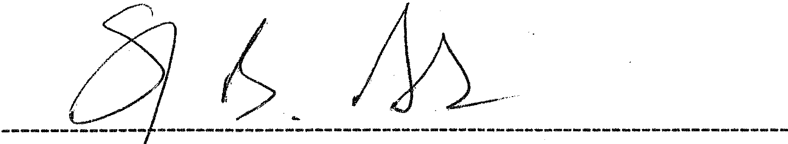
iunGE ST PHEN B. ABLES, 6rn ADMINISTRATIVE JUDGE KERR COUNTY COURTHOUSE, KERRVILLE, TEXAS 78028

